

Programme Name: ________BCs.IT_______________________________________

Course Code: __CSC 1403________

Course Name: ________Database concept______________________________

Assignment / Lab Sheet / Project / Case Study No. _4___

Date of Submission: ______5/17/2020_____________

**Submitted By: Submitted To:**

Student Name**: Dipesh Tha Shrestha** Faculty Name**: Amar Subedi**

IUKL ID: Department**: PO**

Semester**: Second Semester**

Intake**: September 2019**

1. Insert values into the table without specified column values  
   Define: to insert value in the rows of the table without specifying the name of the column

Output:

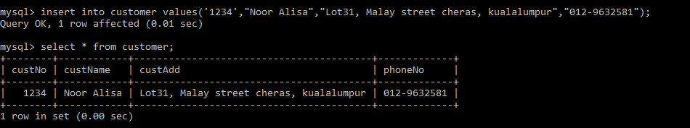

1. a. Creating table customer

Define: to create a table named customer

Output:  
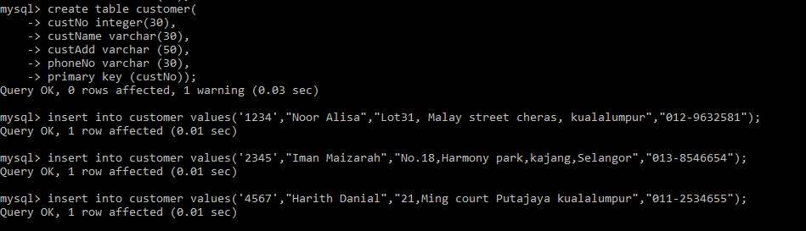

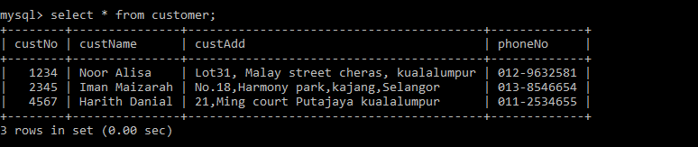

b. create a table named seat  
Define: to create a table named seat

Output:  
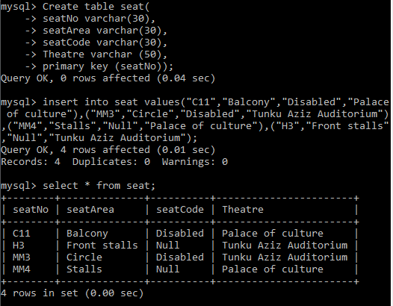

1. Create a table named Booking:

Define: to create a table named booking

Output:  
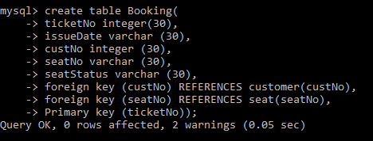

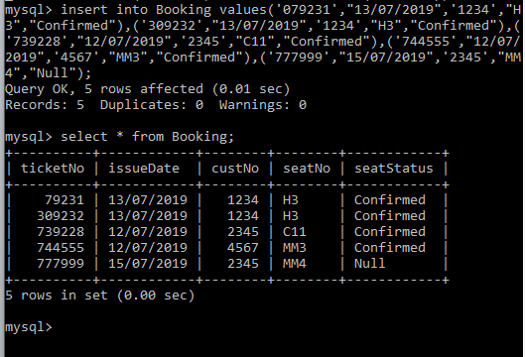

1. Cross join  
   Define: to match each row of customer with each row of booking where custNo is same.

Output:  
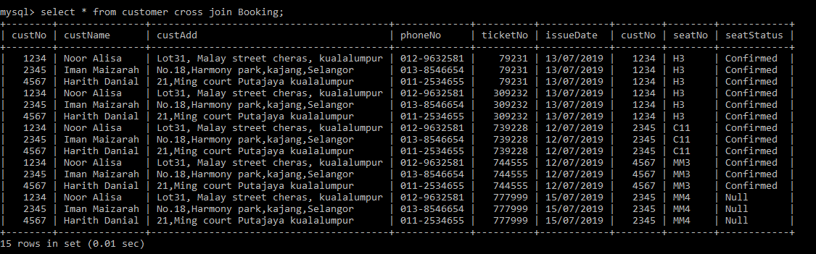

1. Right join

Define: to return all records from the right table (customer), and the matched records from the left table (Booking).

Output:  
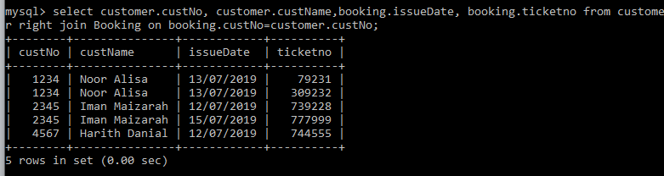

1. Inner join

Define: to select records that have matching values in both tables.

Output: